**Journey Through The Bible**

**Noah**

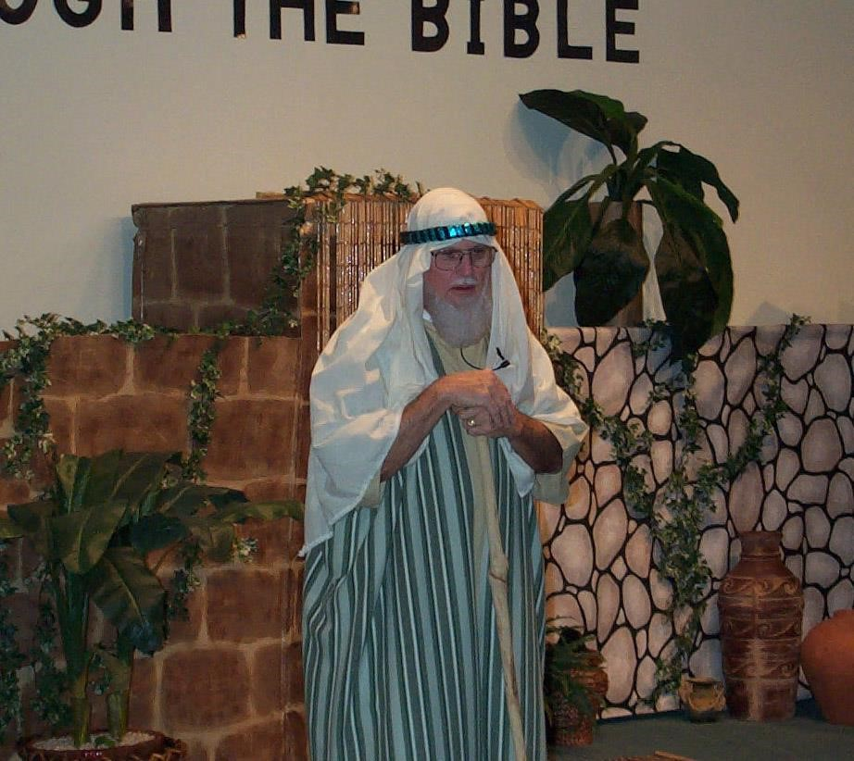

My name is Noah and I am 600 years old. I have a wife, three sons: Shem, Ham, and Japheth and they each have a wife, so that is a total of eight people in my family. I love the Lord and have always tried to obey his teachings and so has my family. None of the other people on the earth loved God or would obey Him.

One day, God spoke to me and told me to build an ark. Now this ark was very, very big. It was 450 feet long (that is the length of 1½ football fields). It was 75 feet wide and 45 feet high. It had three decks—the lower, middle and upper. Now that was a big ark.

God told me that He was going to send a great flood to destroy all living things. Only the eight members of my family would be saved.

After we built the ark, we had to get seven of every clean animal and two of every unclean animal on the ark. Some of the animals and creatures we had to get were the cows, sheep, elephants, giraffes, lions, monkeys, dogs, cats, even flies, bees, fleas, had to be put on the ark. There was one creature that we did not have to be put on the ark. The fish did not have to go on the ark. They could stay in the water! We not only had to take the animals, we also had to take enough food for all of them and for ourselves.

Then it started to rain and it rained and rained! It rained for 40 days! The ark kept rising until it was higher than mountains, even 20 feet higher than the mountains. The water flooded the earth for 150 days.

But God did not forget about me and my family and all of the animals. He sent a wind over the earth and the water started to go away. At the end of 150 days, the water had gone down and the ark came to rest on the mountains of Ararat. The water kept going down until I could see the tops of the mountains.

I opened the window of the ark and sent a raven out and it flew back and forth until the water dried up. Then I sent a dove out and the dove flew around and came back because it couldn’t find a place to rest. I waited seven more days and sent the dove out again. This time when it came back, it had an olive leaf in its beak, so I knew that the water was going down even more. I waited seven more days and sent the dove out again and it did not come back this time so I knew that it had found a place to stay.

Then I took the covering off the ark and could see the ground was dry. God told me to come out of the ark and bring my wife, my three sons and their wives. He also told me to bring out all of the living creatures, the birds, the animals and all other living creatures. My family and I came out of the ark and I built an altar to the Lord and we worshipped Him.

Then the Lord spoke to me and said that He would never, ever destroy the earth with floods again. He also told me that He would make a sign between Him and me and for all of the people that had not even been born. Do you know that that sign is? It is the beautiful rainbow that you see in the clouds after a rain. So, whenever you see the rainbow, you can remember that this sign has been in the sky for thousands of years because that is God’s promise, not just to me, but to you also, not to floor all of the earth again.

This story is from the book of Genesis. Now I would like to ask you some questions about me and my story. (Prepare a few questions to ask the boys and girls about your character.)

**Scripture reading**: Genesis 27:1-41; 33:1-16

**Memory Verse:** Exodus 3:12 "I will certainly be with you.